**Recovery and Failed**

**R31113Z1I_MOM0100**

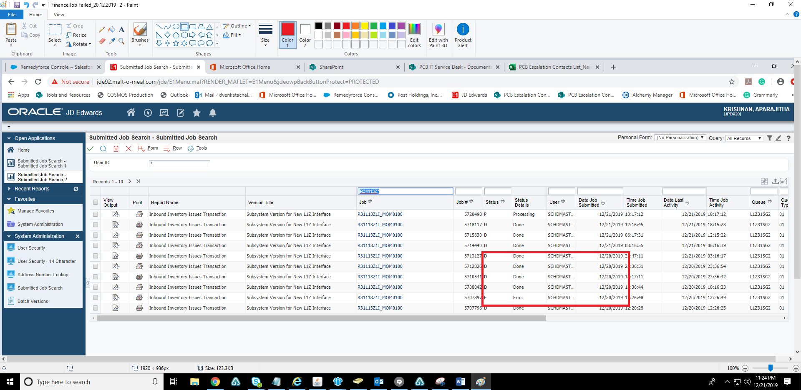

**R47071_MOM0100**

